DEPARTMENT OF COMPUTER SCIENCE AND ENGINEERING

PROJECT TITLE: Atria Connect – Online No Due & Hall Ticket Clearance Portal
PROJECT MEMBERS:
GUIDE: Prof. Keerthi K.S

SL No | Name | USN | Department

PROJECT DESCRIPTION:
Atria Connect is a web-based portal that digitises the No Due clearance students must complete before their examination hall tickets are issued. Instead of carrying a paper form from department to department for signatures, every stakeholder reviews and approves the student online, and the student can follow the progress of their clearance in real time.
Modules / User Roles:
• Administrator – assigns faculty to subjects section-wise, bulk-uploads student data through CSV files, and issues or revokes hall tickets once every condition is met.
• Faculty – sees only the subjects assigned to them and marks each student Cleared or Not Cleared; a reason is mandatory when a subject is not cleared.
• Accounts – records hostel, library and tuition fee dues for each student, individually or through a CSV upload.
• Class Coordinator – reviews clearances, dues and uploaded documents, then signs off or rejects with written feedback.
• Student – views subject-wise clearance, pending dues and approval status, and uploads supporting documents such as certificates (PDF or image).
Workflow:
Faculty Clearance → Dues Settled → CC Sign-off → Hall Ticket Issued
The server enforces this order, so a hall ticket can never be issued while a subject or due is still pending, and every action is recorded in the student's activity log.
Technology Stack: Next.js 15 and React 19 with Tailwind CSS for the user interface; Next.js API routes on Node.js for the backend; MongoDB with Mongoose for data storage; JWT sessions in HTTP-only cookies with bcrypt-hashed passwords; deployed on Vercel with Vercel Blob for document storage.
Security: role-based access control checked on every request, login attempt limiting, file-type verification for uploads and server-side validation of all inputs.

SCREENSHOTS:
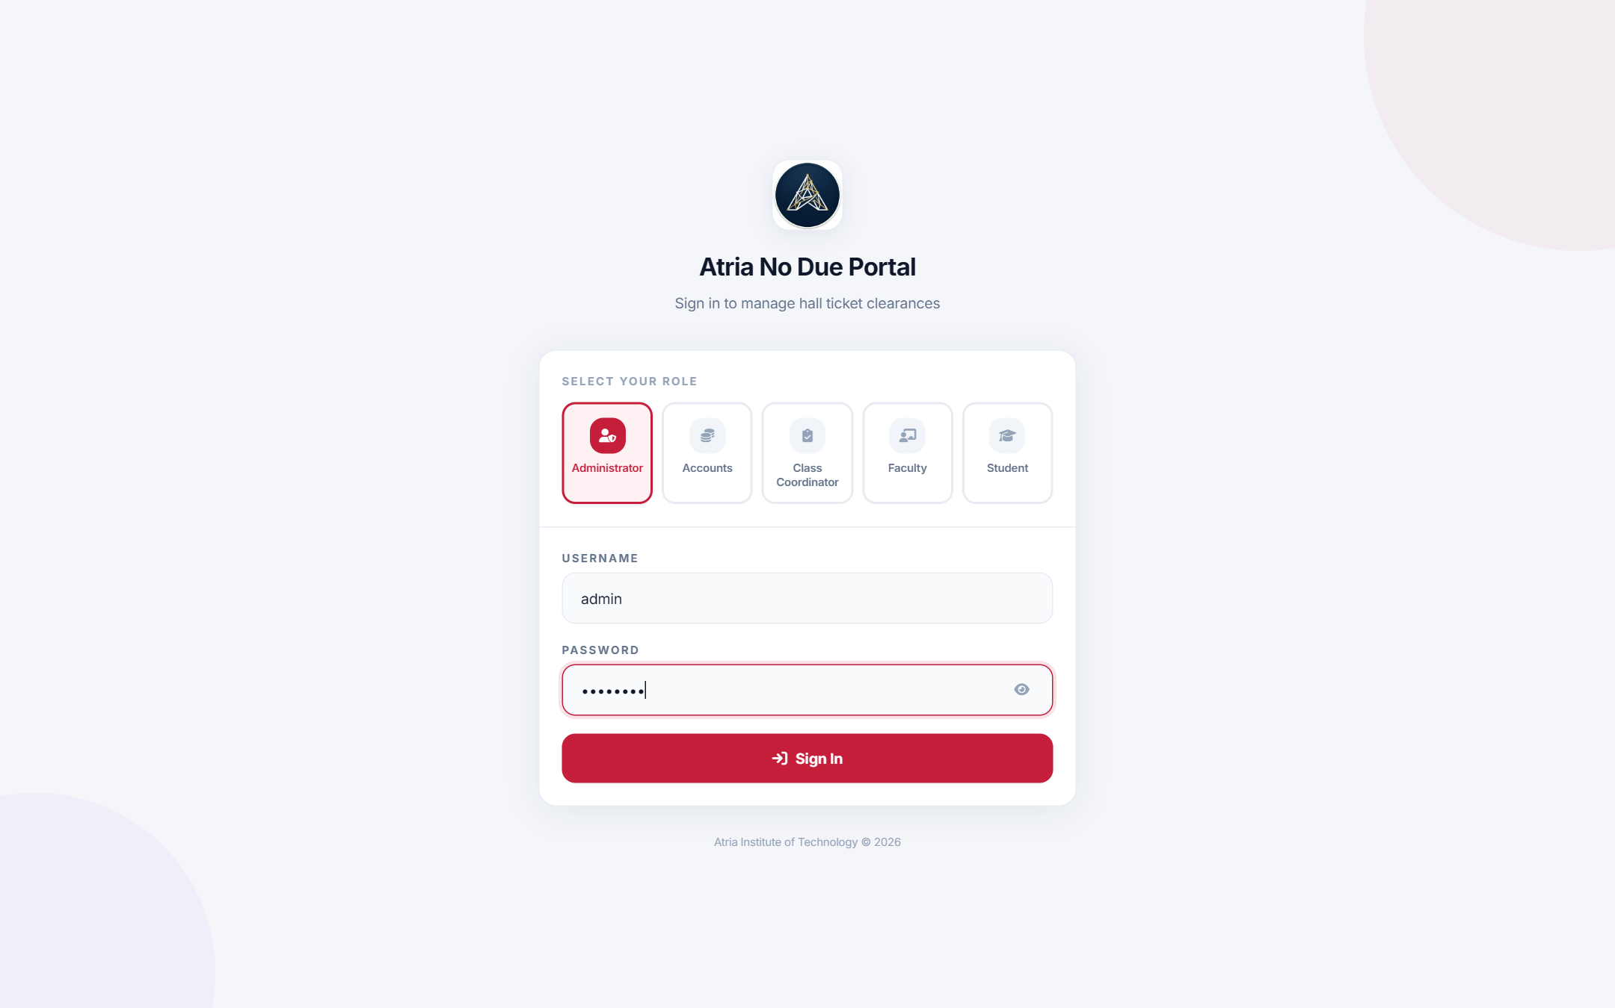  Fig. 1: Login page with role selection | 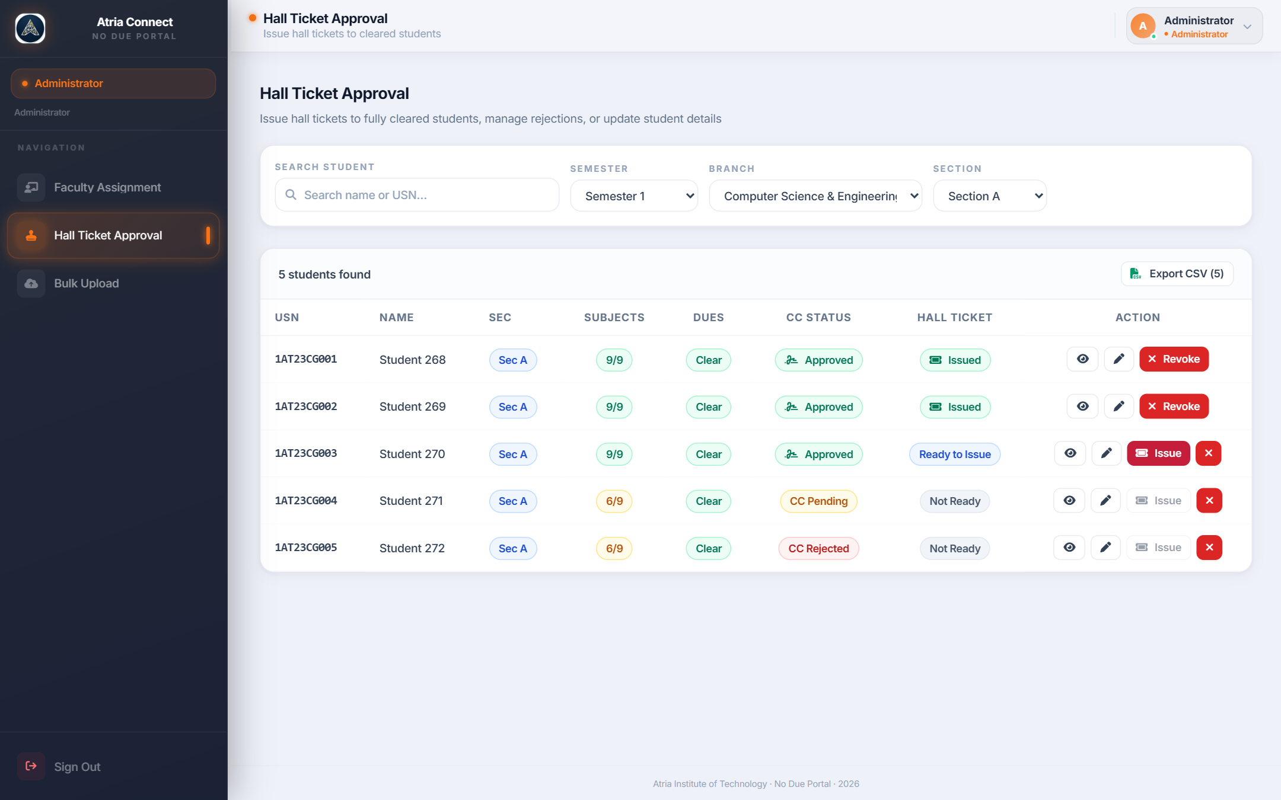  Fig. 2: Administrator – Hall Ticket Approval
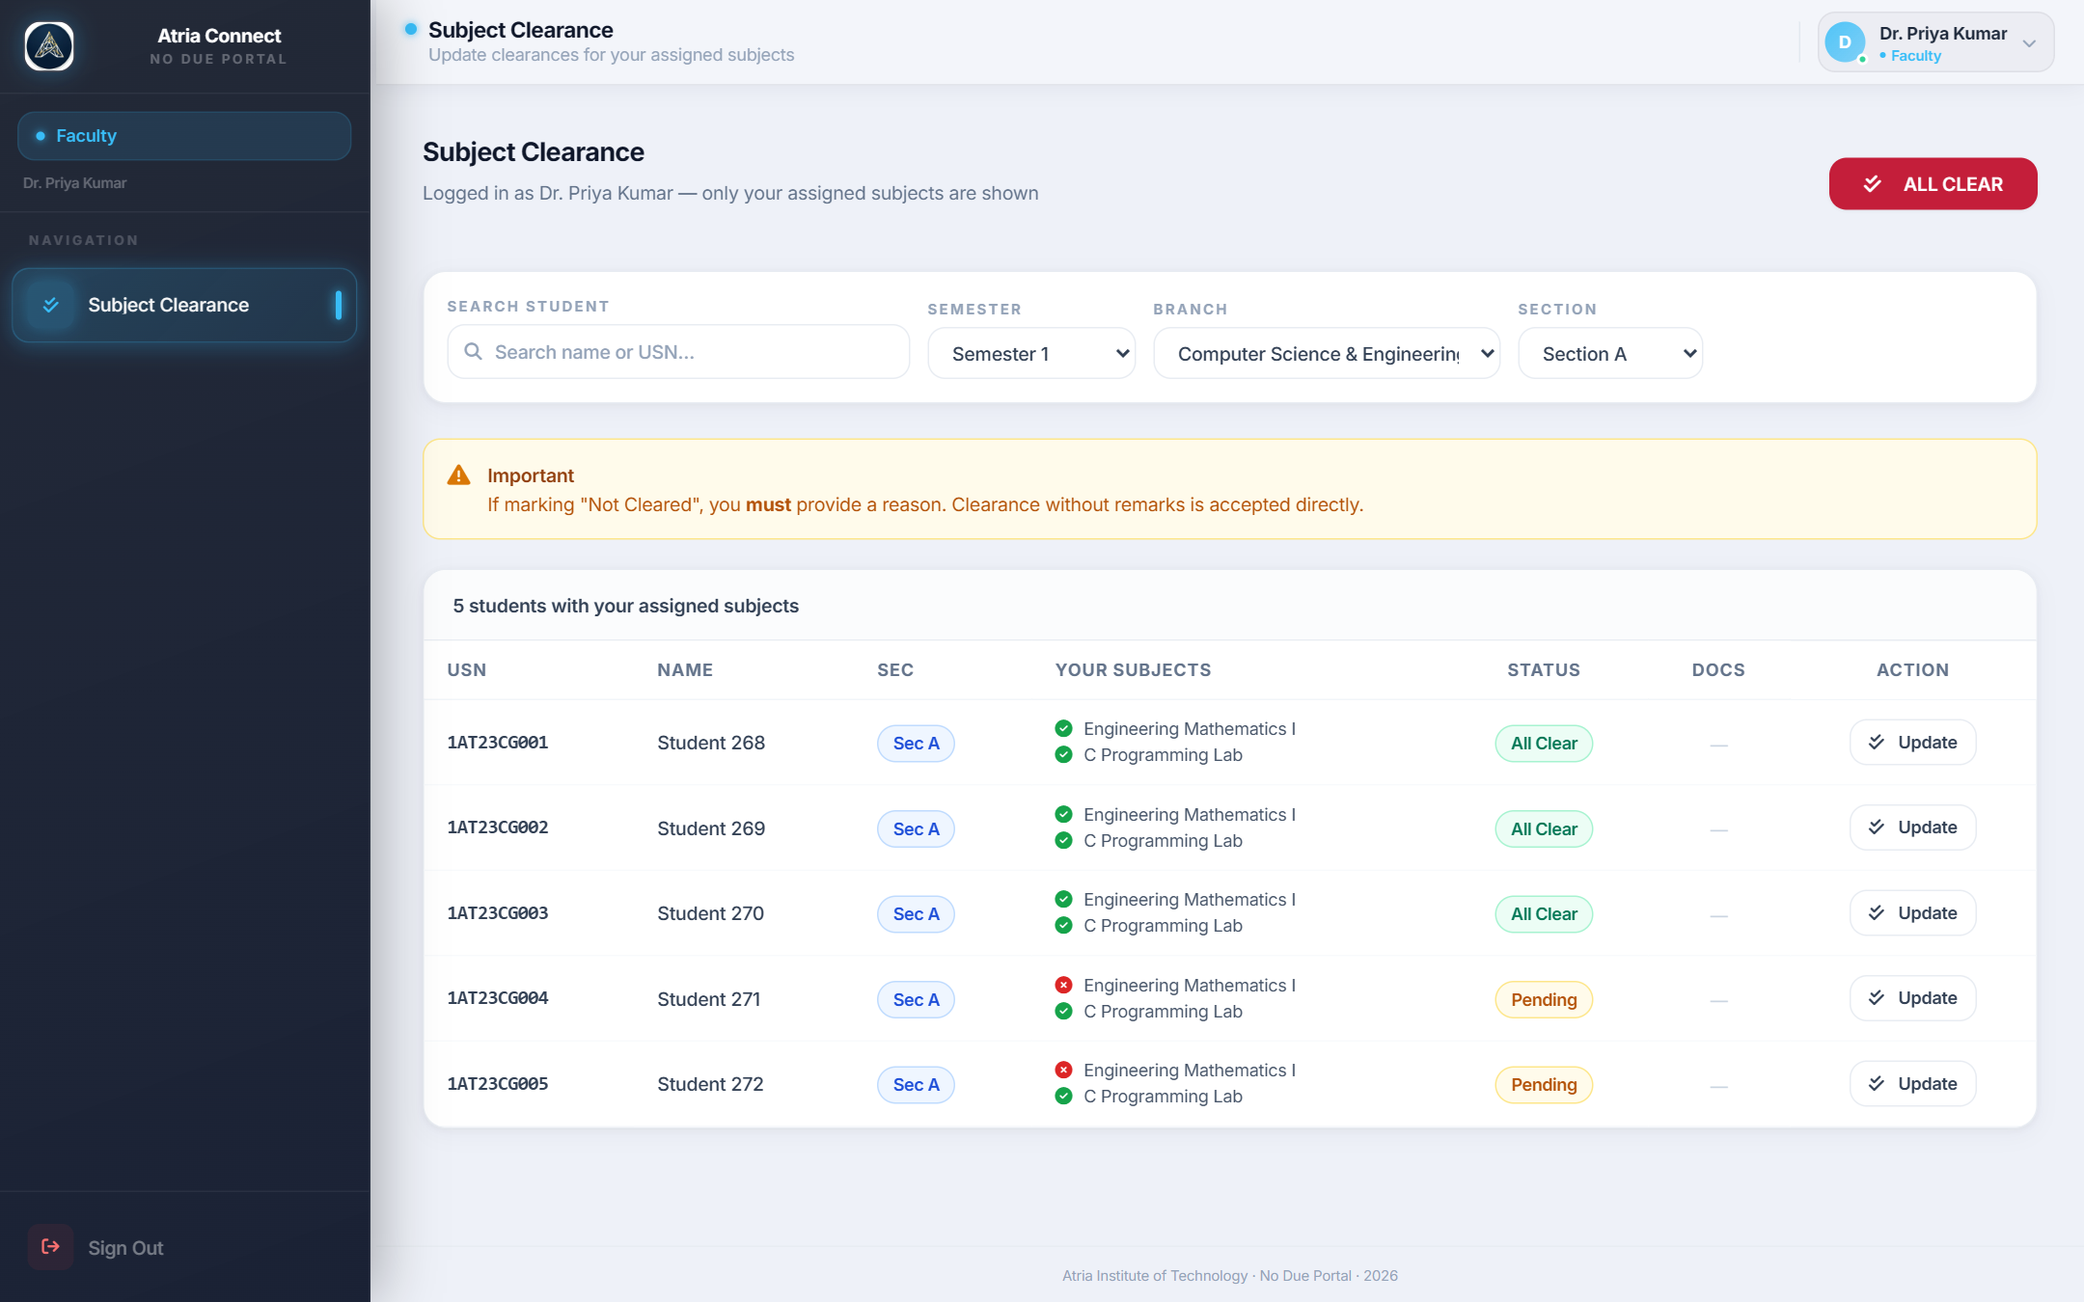  Fig. 3: Faculty – Subject Clearance | 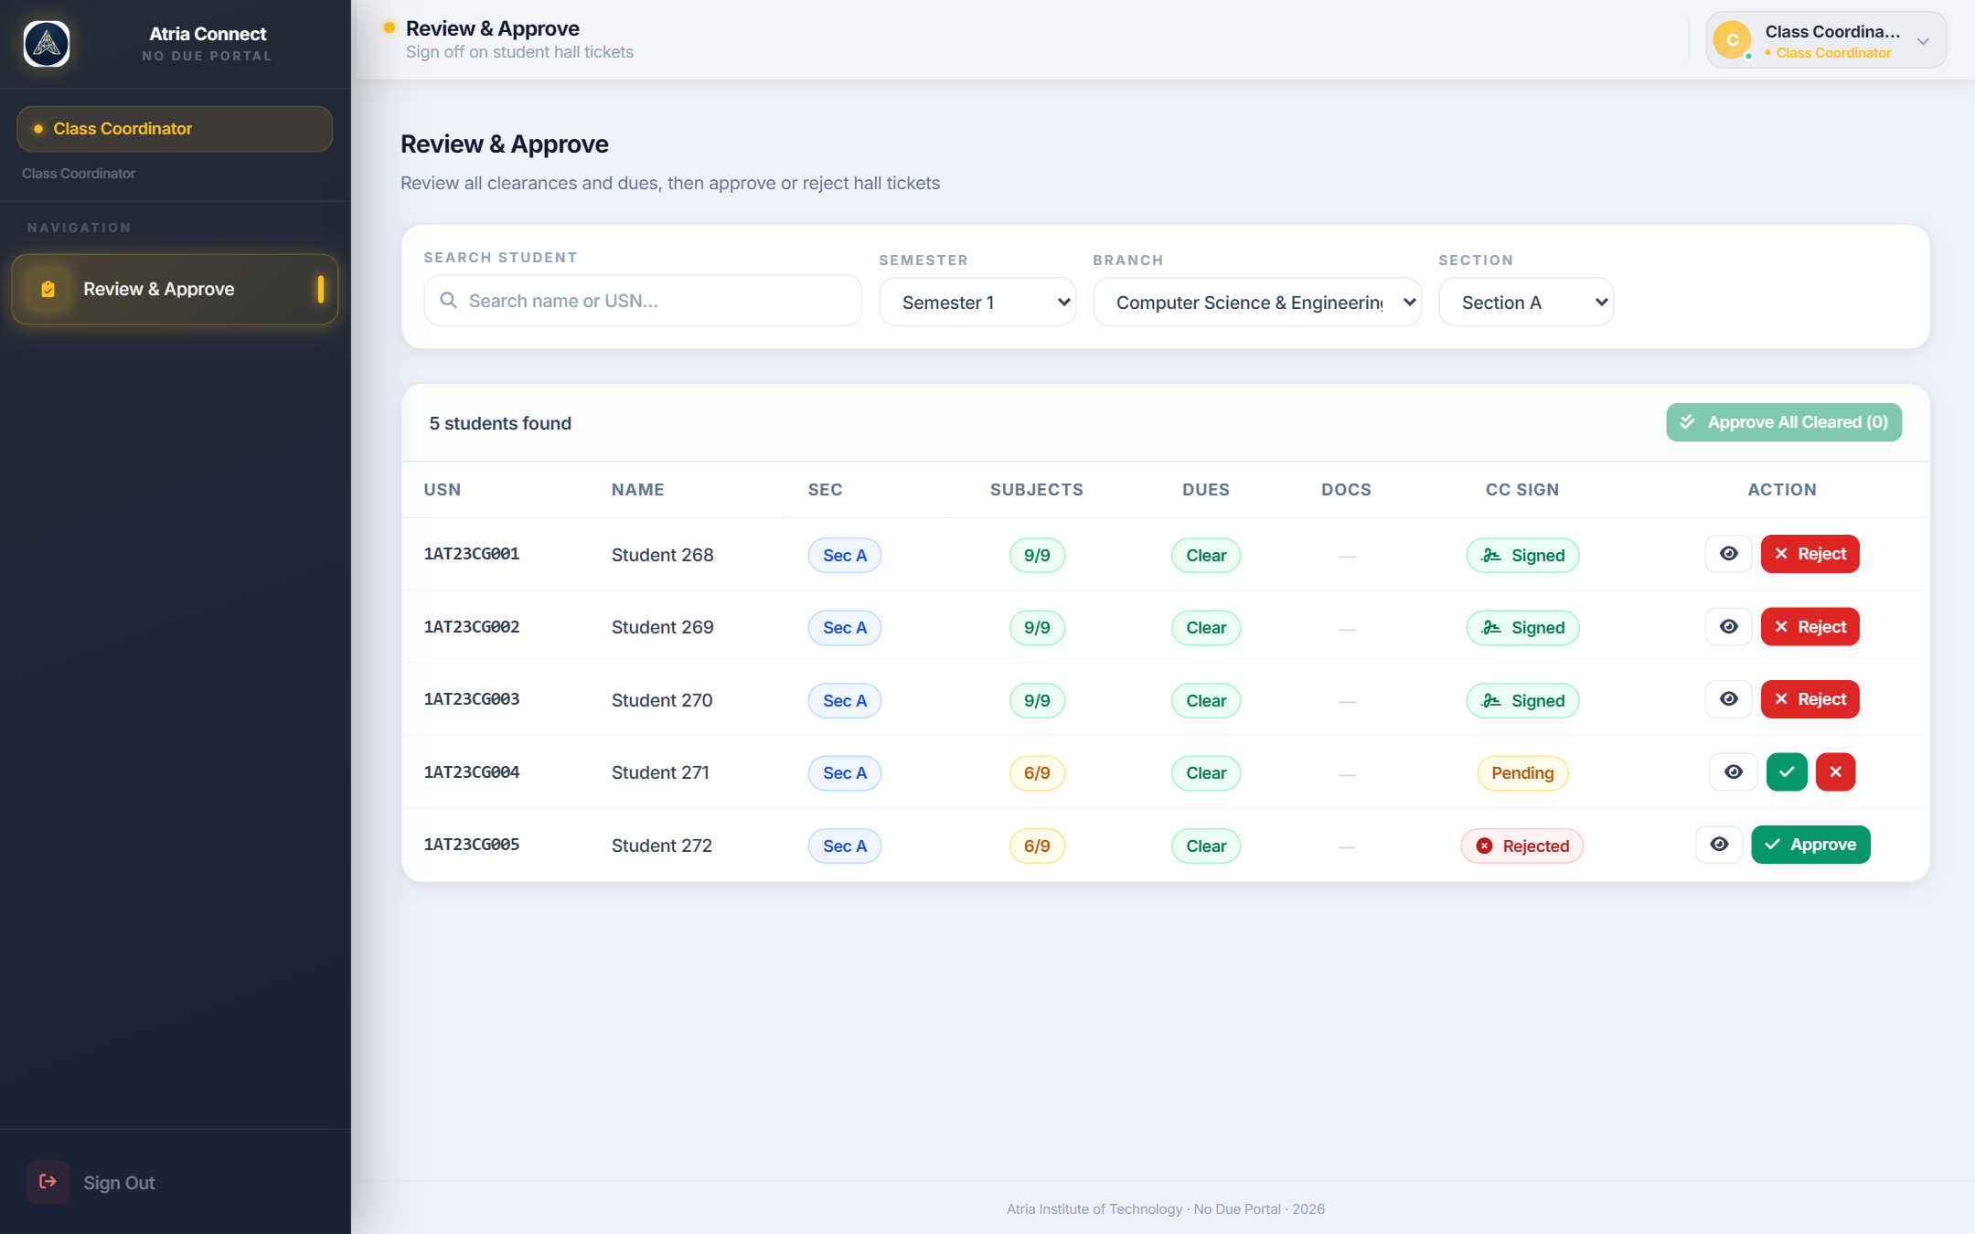  Fig. 4: Class Coordinator – Review & Approve
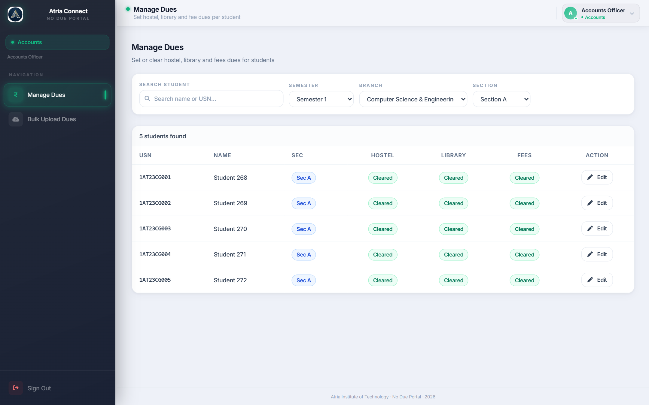  Fig. 5: Accounts – Manage Dues | 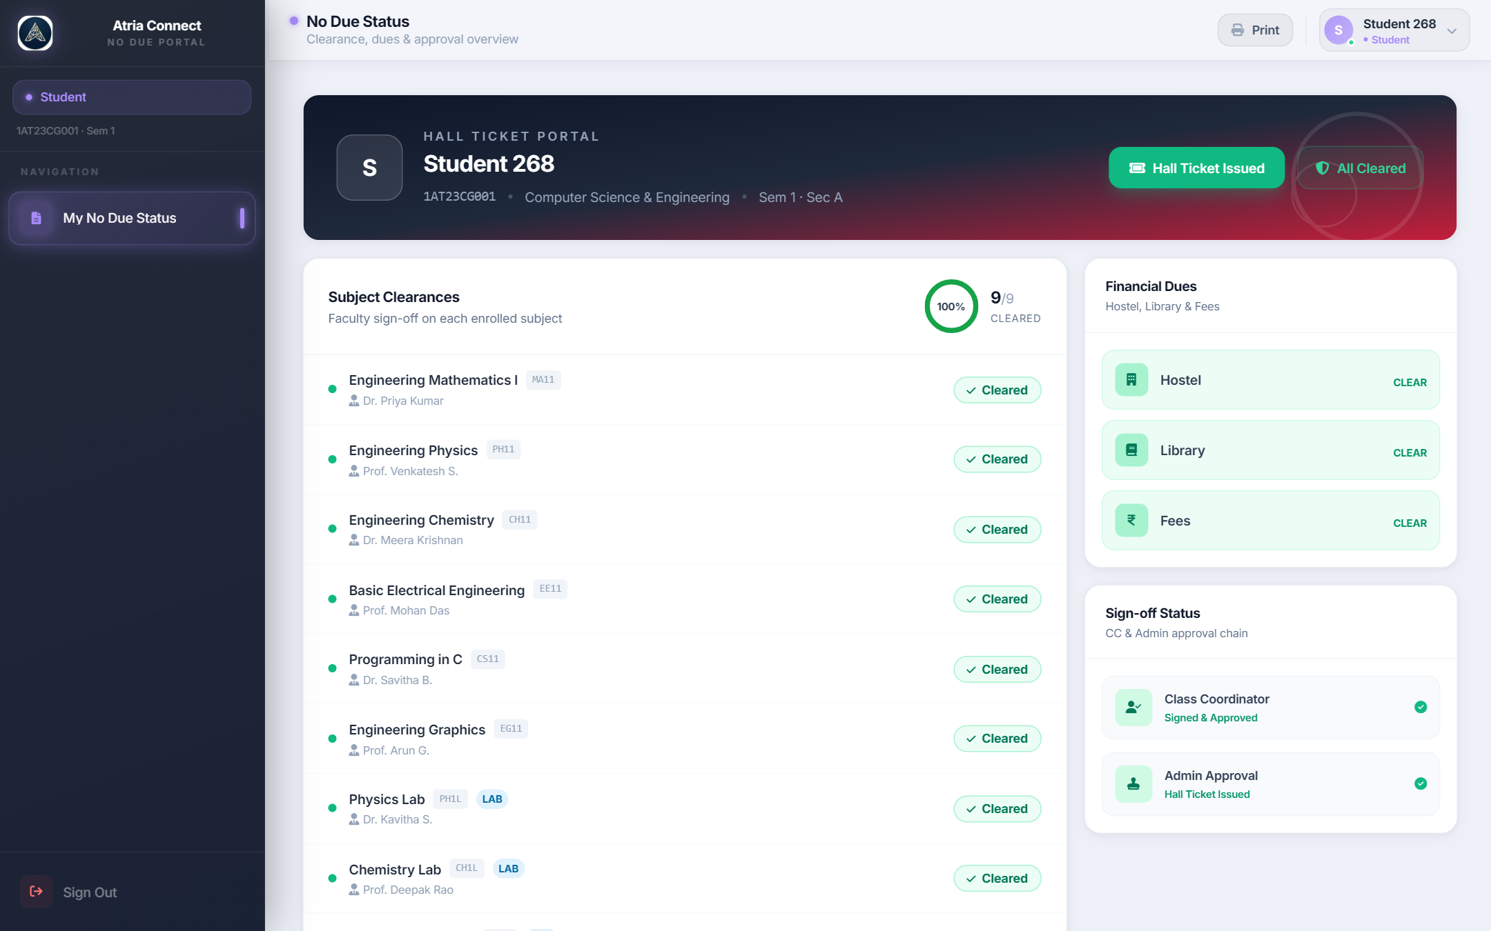  Fig. 6: Student – No Due Status

Club Co-ordinator Signature HOD Signature

